*Florida International University*

*School of Computing and Information Sciences*

CIS 4911 - Senior Capstone Project

Software Engineering Focus

Feature Document

User Story # 970

**Team Member:**

Daniel Lopez

**Product Owner(s)**:

Mohsen Taheri

**Mentor(s)**:

Mohsen Taheri

**Instructor**:

Mohsen Taheri

**User Story** Display Current User When Logged In

**Description**

As a user when I login I want the current user to be displayed in the header of the web page. So the user can know which account is logged in.

**Acceptance Criteria**

1. Current user displayed in header.
2. When logged out user display shows nothing.

**Use Case**

1. Participating Actors: User  
     
   Entry Condition: Signs into website.  
     
   Events Flow:
2. See current User display in header of website.
3. Can click link to profile page.

**Use Case Diagram**

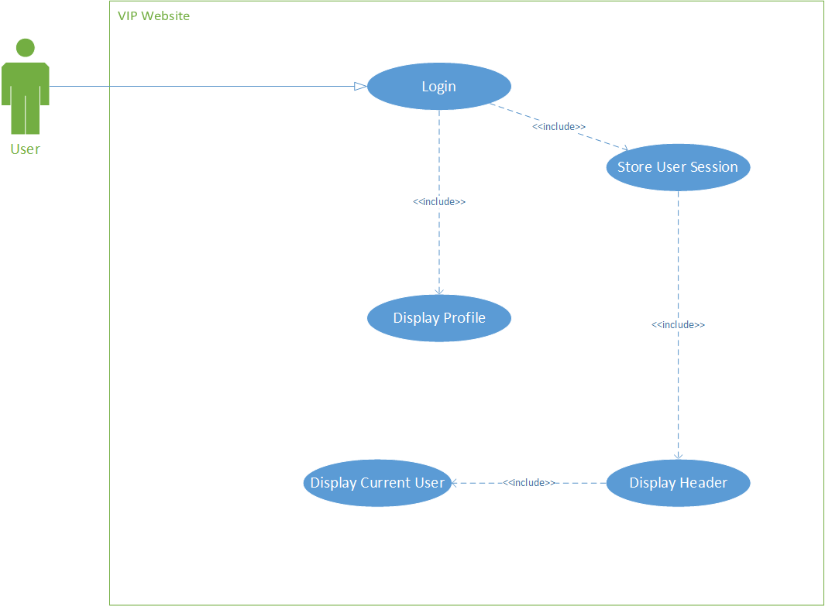

**Sequence Diagram**

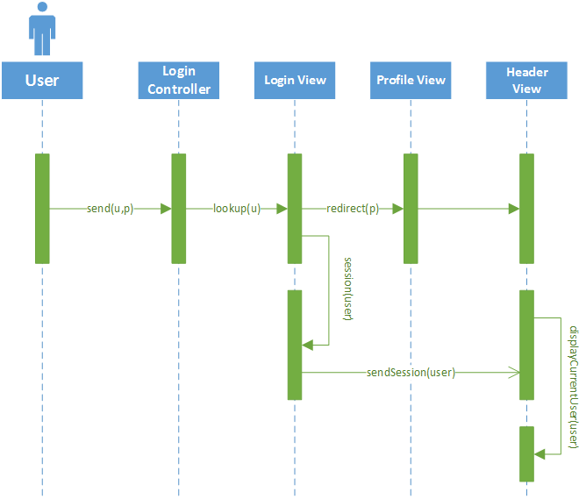

**Class Diagram**

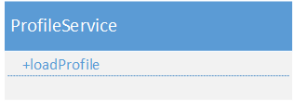

**Unit Test & Integration Test**

* **Test Case 1**
  + **Purpose:** Test that when user logs in name of user gets displayed with link to header.
  + **Precondition:** User must be logged in.
  + **Expected Result:** Welcome X! Where X is user’s name and X is a clickable link to profile.
  + **Actual Result:** Same as expected.
  + **Status: PASS**
* **Test Case 2**
  + **Purpose:** Test when a user logs out the display name and profile page links disappears.
  + **Precondition:** Logged out or not logged in.
  + **Expected Result:** Login display showed and To-Do displayed only.
  + **Actual Result:** Same as expected.
  + **Status: PASS**

**Visual User Guide**

